Wausau Tile is Expanding and Rebranding
European Connection Moves Wausau Tile to the Next Level

By: Jim Servi
jservi@thebusinessnewsonline.com

Wausau Tile has always had a strong brand name, but they’re looking to take it to the next level with recent rebranding efforts and the upcoming completion of their 100,000 square foot expansion. With the expansion and rebranding efforts, Bryan Borrell, President of Wausau Tile, expects “substantial growth over the next five years.” The reason for the rebranding is to highlight their impressive line of capabilities and not be limited by the word tile in their company name. Yes, they produce tile, but that is only a small portion of their operations. To highlight a complete look at their capabilities, they started down the path of rebranding in late 2013 and made the official launch in June 2015. The result was Tectura Designs and Wausau Made, both of which will continue to fall under the Wausau Tile, Inc. umbrella.

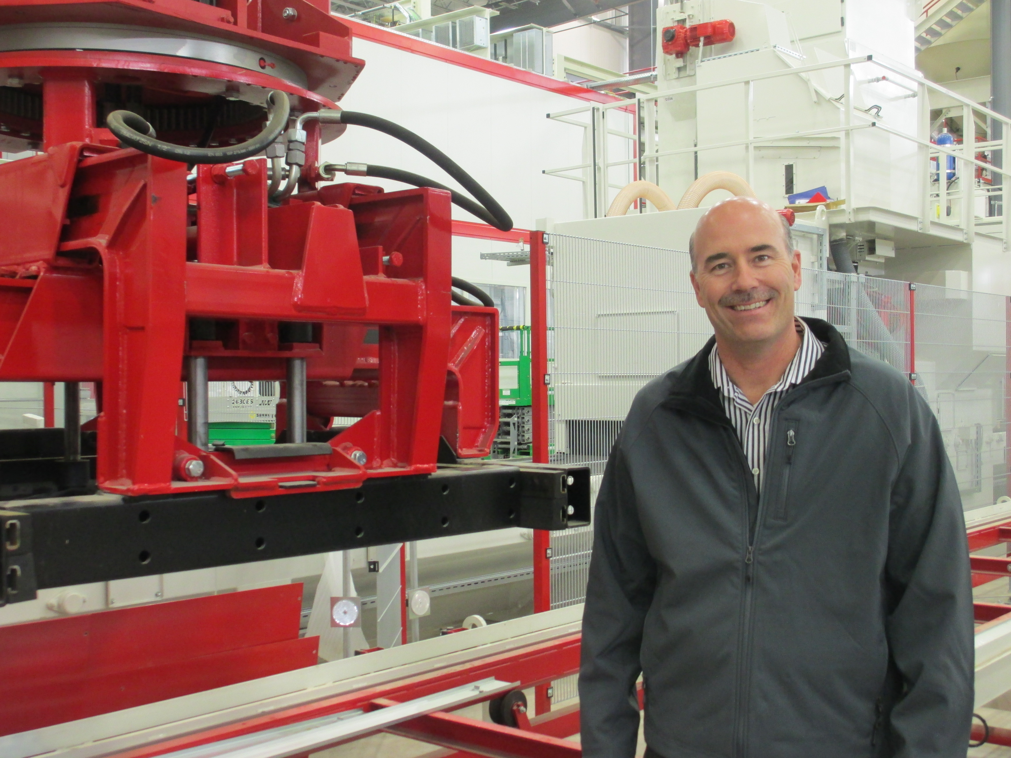

As part of a larger plan, the launch of the new branding effort coincided with breaking ground on a new 100,000 square feet manufacturing facility just down the road in Kronenwetter. Tectura Designs’ new paver facility can produce more than 60 sizes of pavers and take their customization to a whole new level. “No one can replicate it in the country,” declares Rob Geurink, Wausau Tile General Manager. That’s exactly what they’d like Tectura Designs to be known for – as the premier provider of architectural products. This includes site furnishings, concrete pavers, custom precast concrete, custom precast terrazzo and terrazzo tile. In the words of Geurink, “this moves us from AAA to the Major Leagues.” Or the Super Bowl for that matter. They can now compete for jobs they couldn’t consider in the past. One of these is a project in Minneapolis where they are part of the team working on the new U.S. Bank Stadium as they prepare to host Super Bowl LII in 2018. “Our capabilities and scope is expanding, and now we can do the whole package,” explained Borrell.

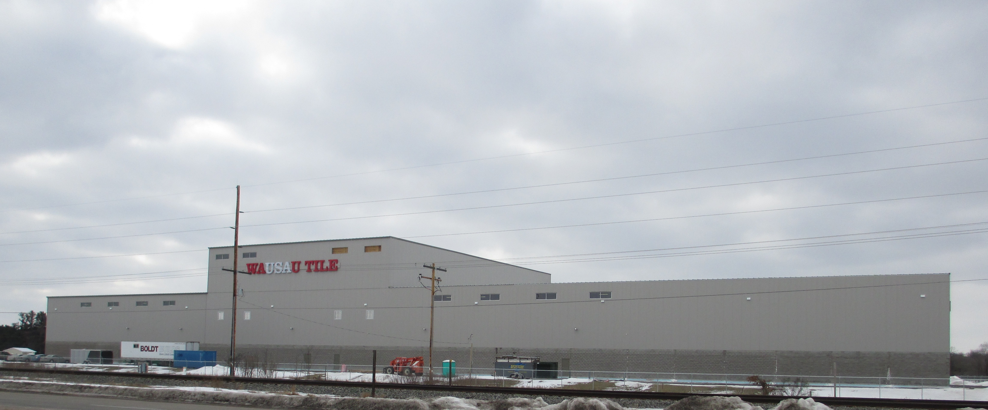

“We’ve made the strongest, longest-lasting concrete pavers on the market for more than 40 years, and now we’re giving our customers even more creative control,” said Rodney Dombrowski, paving division manager for Tectura Designs. “As we’ve started to tell architects about what this new facility can do for them, they can barely contain their excitement. I’m really looking forward to seeing what some of our customers can do with these new capabilities.”

Wausau Made, on the other hand, has standard offerings of concrete and metal that you can find in every McDonald’s, local parks or while walking downtown. Their products include your standard waste and recycling containers, benches, planters, bollards, tables, snuffers and park furnishings. Both Tectura Designs and Wausau Made are linked to Wausau Tile, but each one has their own identity and unique characteristics. However, they can also work hand in hand. By exposing customers to one or the other, Wausau Tile will make customers aware of the other. This is perfect since many large projects need both customizations to make them unique but standard offerings to give the project purpose. Wausau Tile has always been able to do both, but thanks to their rebranding the rest of the country is beginning to see that as well.

They’ve been actively pushing the expansion by attending trade shows, issuing press releases and putting advertisements in national magazines. By doing this, they plan to “be taking orders by spring and will be up and running in May,” according to Borrell. Their efforts appear to be working with visits from three different groups from across the country – Texas, New York and Chicago – in a ten day period to discuss paving and custom concrete. Part of their success can be contributed to the knowledge sharing with a German partner. “We have a partner in Germany that leads the market in paving,” said Geurink. The two companies found a common connection and came to a mutually beneficial agreement. “The great thing is they’re learning from us as much as we’re learning from them,” added Borrell.

One amazing aspect of the expansion is that they’ve exclusively used local products and local labor and credit an “unbelievable work ethic” for the reason they were able to finish such a massive undertaking in less than a year. Borrell closed the conversation by saying, “nothing happens if the Creske family doesn’t invest.” Edward Creske founded Wausau Tile in 1953 and his family continues to be involved in the strategic direction of the company. Thanks to the dedication of their employees, a key strategic investment, a little help from a European connection and their rebranding efforts, Wausau Tile is poised to continue to grow in the future.

